11. Orientation of a Palaeo Stress-Ellipsoid (Dihedra Method)
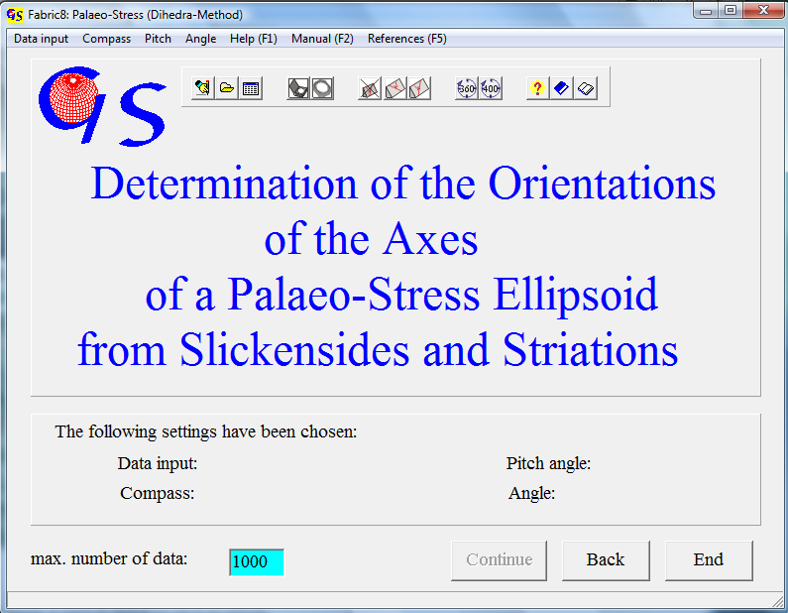
Fig. 1

This program (Fig. 1) calculates the orientation of the three principal stresses σ1, σ2 und σ3 from slickenside planes and striations on them. The polarity of the striation lineation (hanging block up or down) must be clearly defined in the field. The algorithm which was developed according to the method of ANGELIER & MECHLER (1976) works as follows: An auxiliary plane is constructed normal to the slickenside plane and normal to the striation. Both, slickenside plane and the auxiliary plane divide the globe into two compressional dihedra which must contain σ1, and in two tensional dihedra which must contain σ3. The intersecting set of all compressional dihedra is calculated and plotted with the contour lines of 20%, 40%, 60%, 80% und 95% of compression. The liability of the method is controlled by two things: 1. the shear sense on the slickenside plane must be doubtlessly determined. 2. the slickenside planes should have very different orientations. This reduces the size of the of the intersecting set which contains σ1.
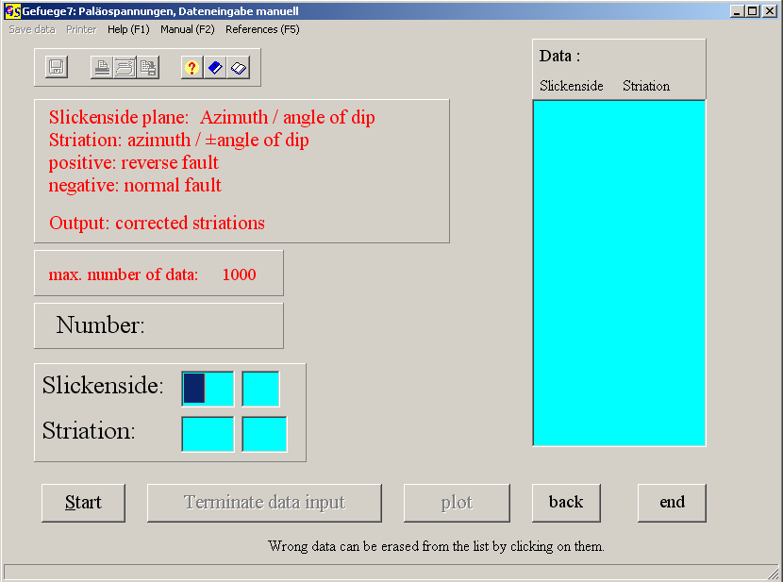
Fig. 2

The starting form contains the menus "Data input", "Compass", "Pitch", and "Angle". Data input can be manually, from a file, or from an Excel sheet. It is the same as in the other programs.
The options of the menu "Compass" tell the program the format of manual data input: Clar compass for direction (azimuth) of dip and angle of dip. Brunton compass for input as direction of strike, angle of dip, and direction of dip. The direction of the striation lineation can also be described by the pitch angle (angle between strike and lineation). In the menu "Pitch" the direction – clockwise or counter clockwise - is set.
After pressing "Start" the orientation slickenside plane is filled in, followed by the orientation of the striation.
Fig. 2 shows the form for manual data input with the Clar compass (Dip azimuth and angle of dip of the Slickenside and the striation). Fig. 3 shows the input fields for the Brunton compass (Strike, dip and direction of dip for the slickenside and striation). Fig. 4 gives the input fields for the plane and the pitch angle.
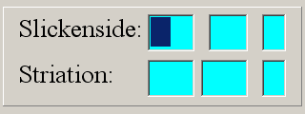
Abb. 3
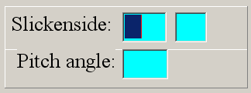
Abb. 4

The dip angle is positive for reverse faults and negative for normal faults. For positive dip angles the sign '+' is not necessary. The orientation of striations is corrected so that the striation is put in the slickenside plane. Input from a file is the same as in the previous programs.
The graphic form is shown in Fig. 5
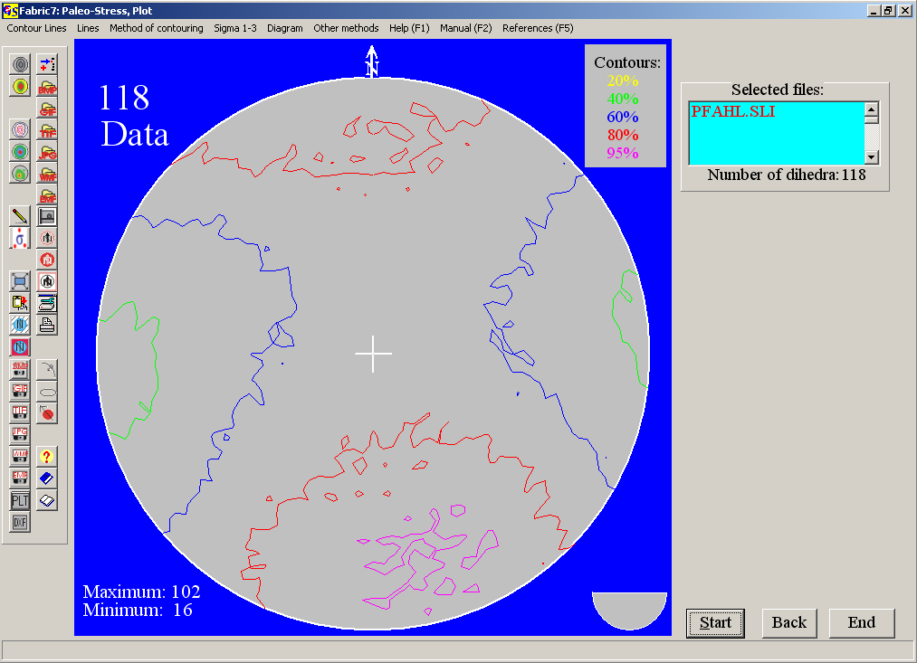
Fig. 5
In the menu “Contour lines” (Fig. 6) the colours of contour lines can be changed.
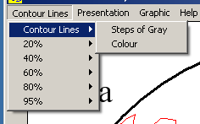 Fig.6

Contours can be plotted either in a scale of gray or in colour (first option).

The applied algorithm works with the methods of set theory. That means that the exact position of σ1 in the 95%-contour cannot be defined. σ3 is situated in the lowest contour. The minimum number of data (in the extensional dihedra) is a measure for the quality of the data set. A consistent data set should have a minimum of zero.
The estimated principal stresses σ₁ and σ₃ can be plotted into the diagram by mouse click. Click on a point in the diagram which represents the estimated direction of one principal stress, then press on the corresponding button. Since the principal stresses are normal to each other, a great circle around the chosen point is drawn. Now click on a point on the great circle which represents another principal stress direction and press the corresponding button. Onother great circle is plotted. Now click on the point of intersection of the two great circles and press the remaining button. After this the graphic will be built up again and the three principal stresses are shown. Their values appair on the right side (Fig. 7).
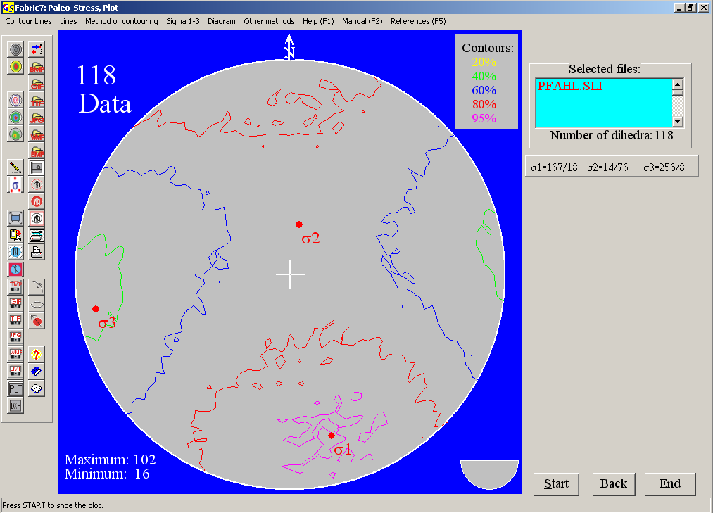
Fig. 7

The colour of the principal stresses is chosen in the menu "Sigma 1-3".

In addition to the vector graphic (Fig. 5) you also have the option of plotting a pixel graphic (bitmap) which gives very smooth contours. The method is the same as in program 9. With the option “Distance Method” of the menu “Method of contouring” (Fig. 8) the transition between the contours can be chosen in steps (Fig. 9) or floating (Fig. 10). The choice of colours for the floating modus is described in 4.9. With the option “Calotte” you return to vector graphis (Fig. 5).

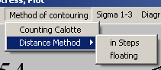 Fig. 8

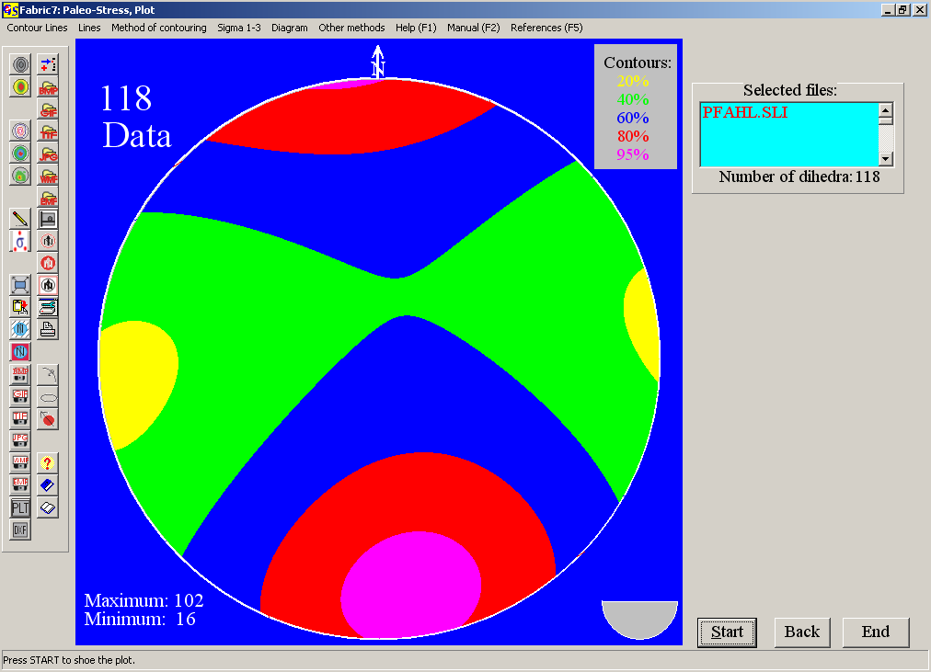 Fig.9

The creation of polylines following the edges of the colours, and the saving of these polylines in a dxf file or printing of these lines (filled or not filled) is the same as in the chapter 'Contour lines'.

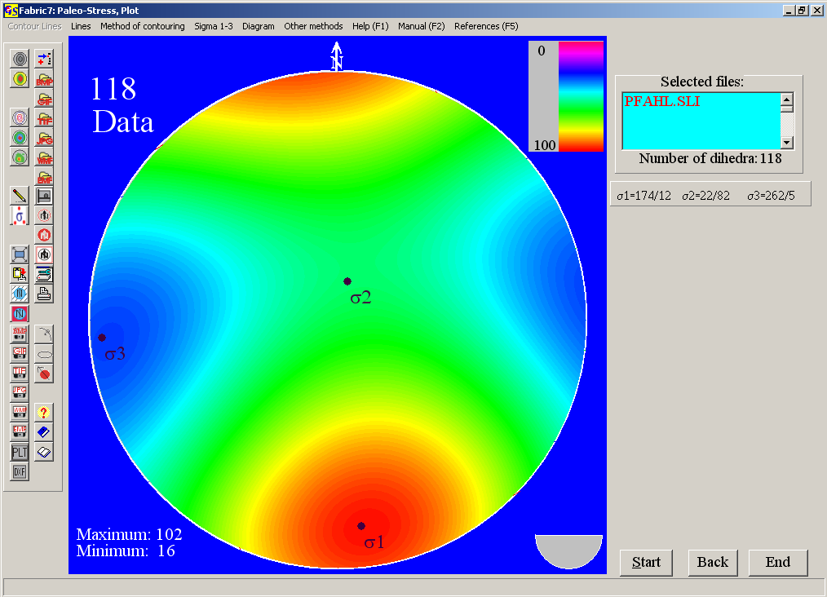 Fig. 10

The menu "Diagram" is described in program 3.

With the menu "Other methode" (Fig. 11) you jump to the other programs which also use displacement data.

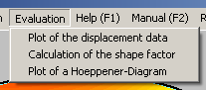
Fig. 11

